**Day 5**

1.      GROUP BY with WHERE - Orders by Year and Quarter

Display, order year, quarter, order count, avg freight cost only for those orders where freight cost > 100

select

extract(year from order_date) as "order_year",

extract(quarter from order_date )as "quarter",

count(*) as "order_count", avg(freight) as "avg_freight"

from orders where freight >100

group by order_year,quarter ;

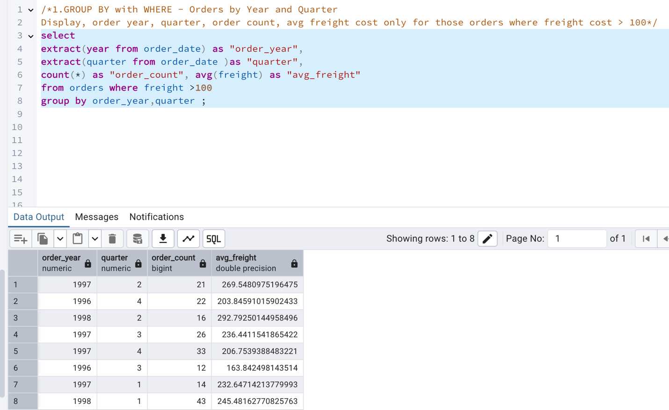

2.      GROUP BY with HAVING - High Volume Ship Regions

Display, ship region, no of orders in each region, min and max freight cost  
 Filter regions where no of orders >= 5

select ship_region,count(*),

min(freight),

max(freight)

from orders

group by ship_region

having count(*)>=5;

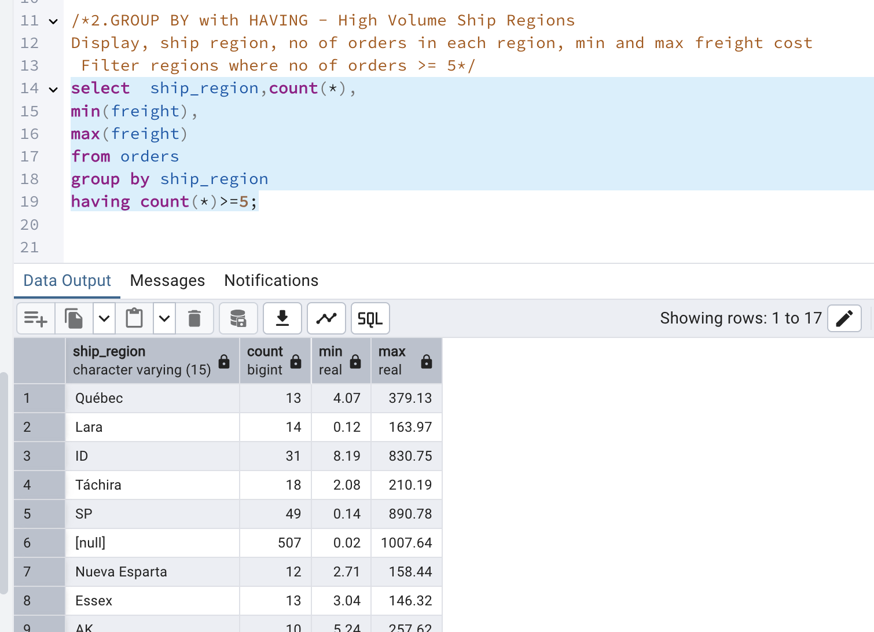

3.      Get all title designations across employees and customers ( Try UNION & UNION ALL)

select title from employees

UNION

select contact_title from customers ;

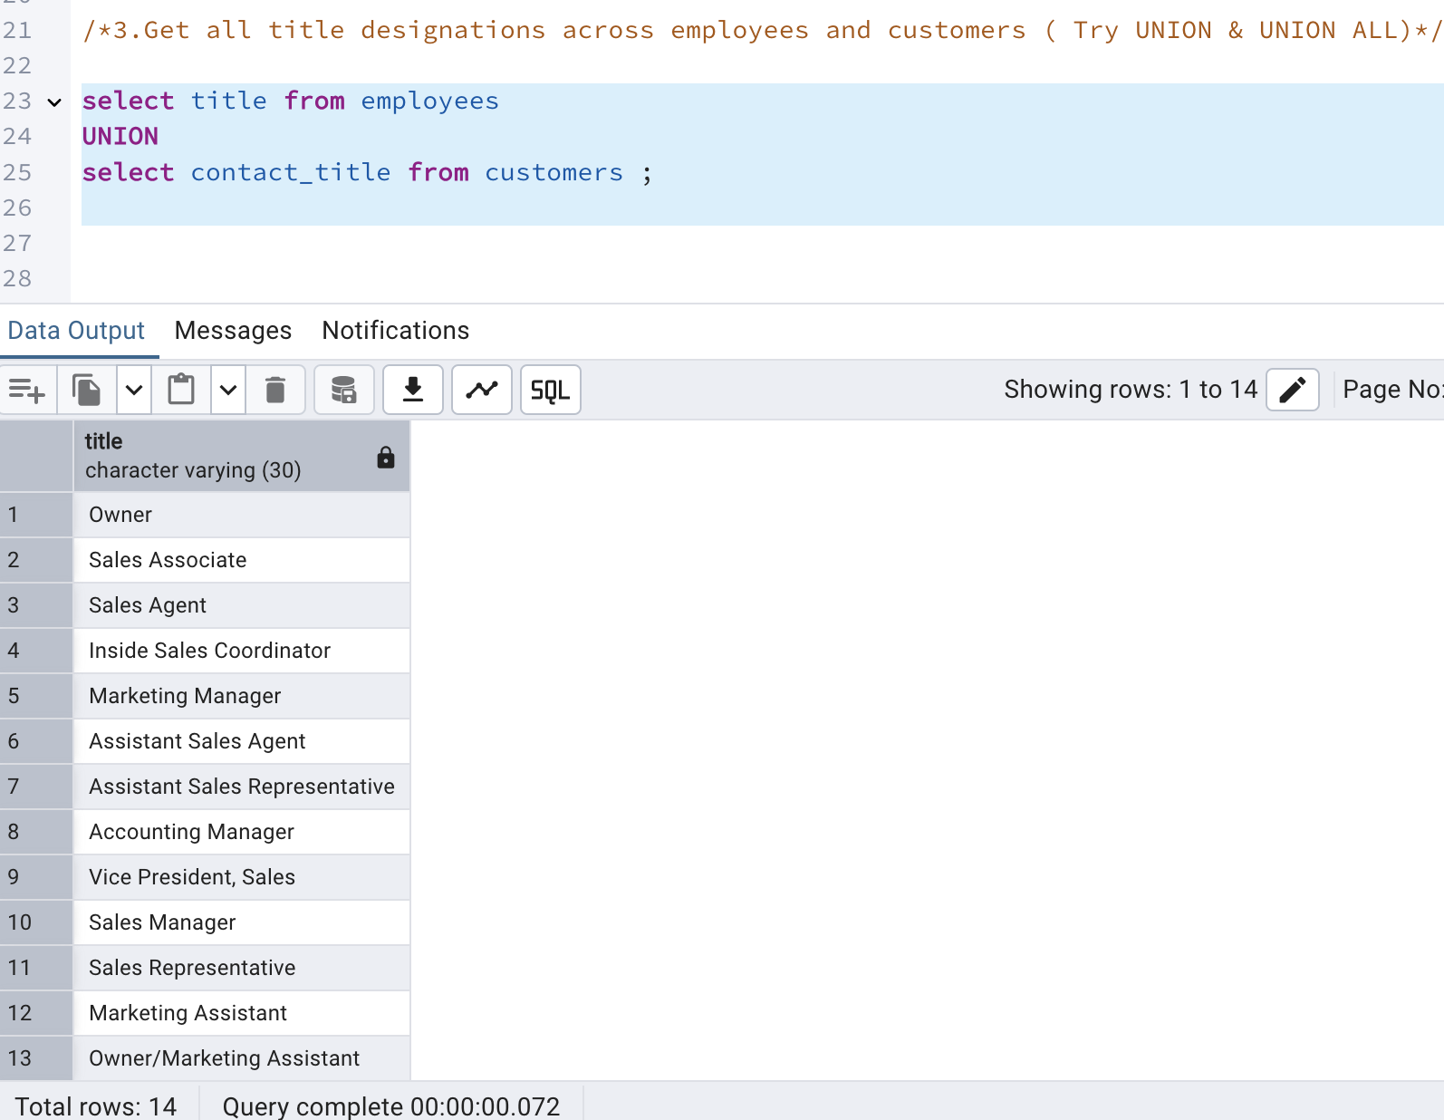

select title from employees

UNION ALL

select contact_title from customers ;

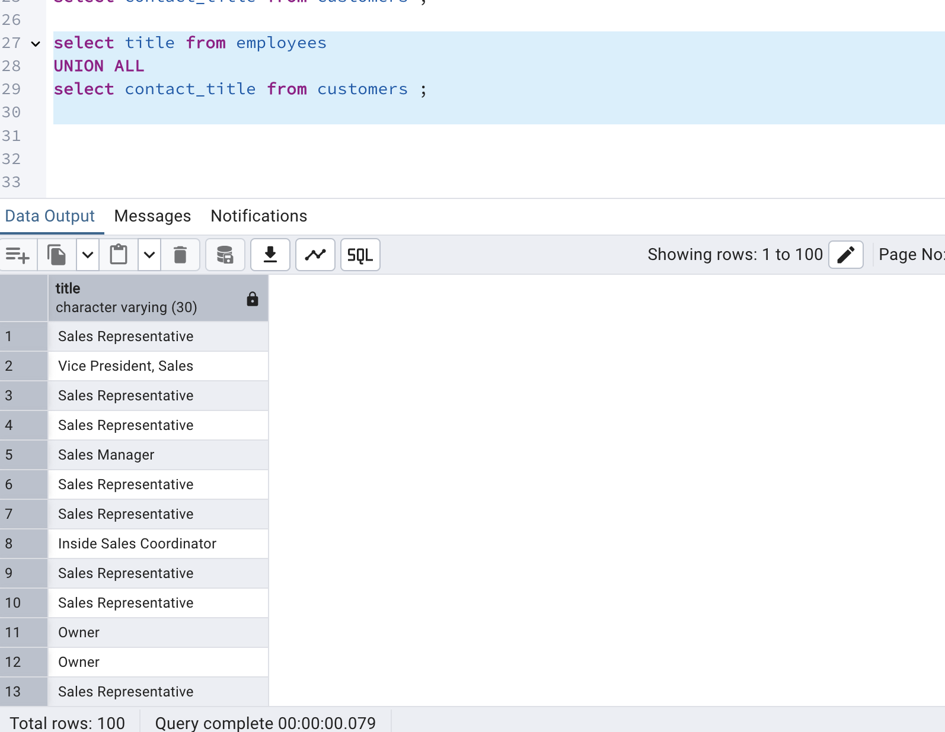

4.      Find categories that have both discontinued and in-stock products

(Display category_id, instock means units_in_stock > 0, Intersect)

select category_id from products where discontinued = 1

INTERSECT

select category_id from products where units_in_stock > 0

order by category_id;

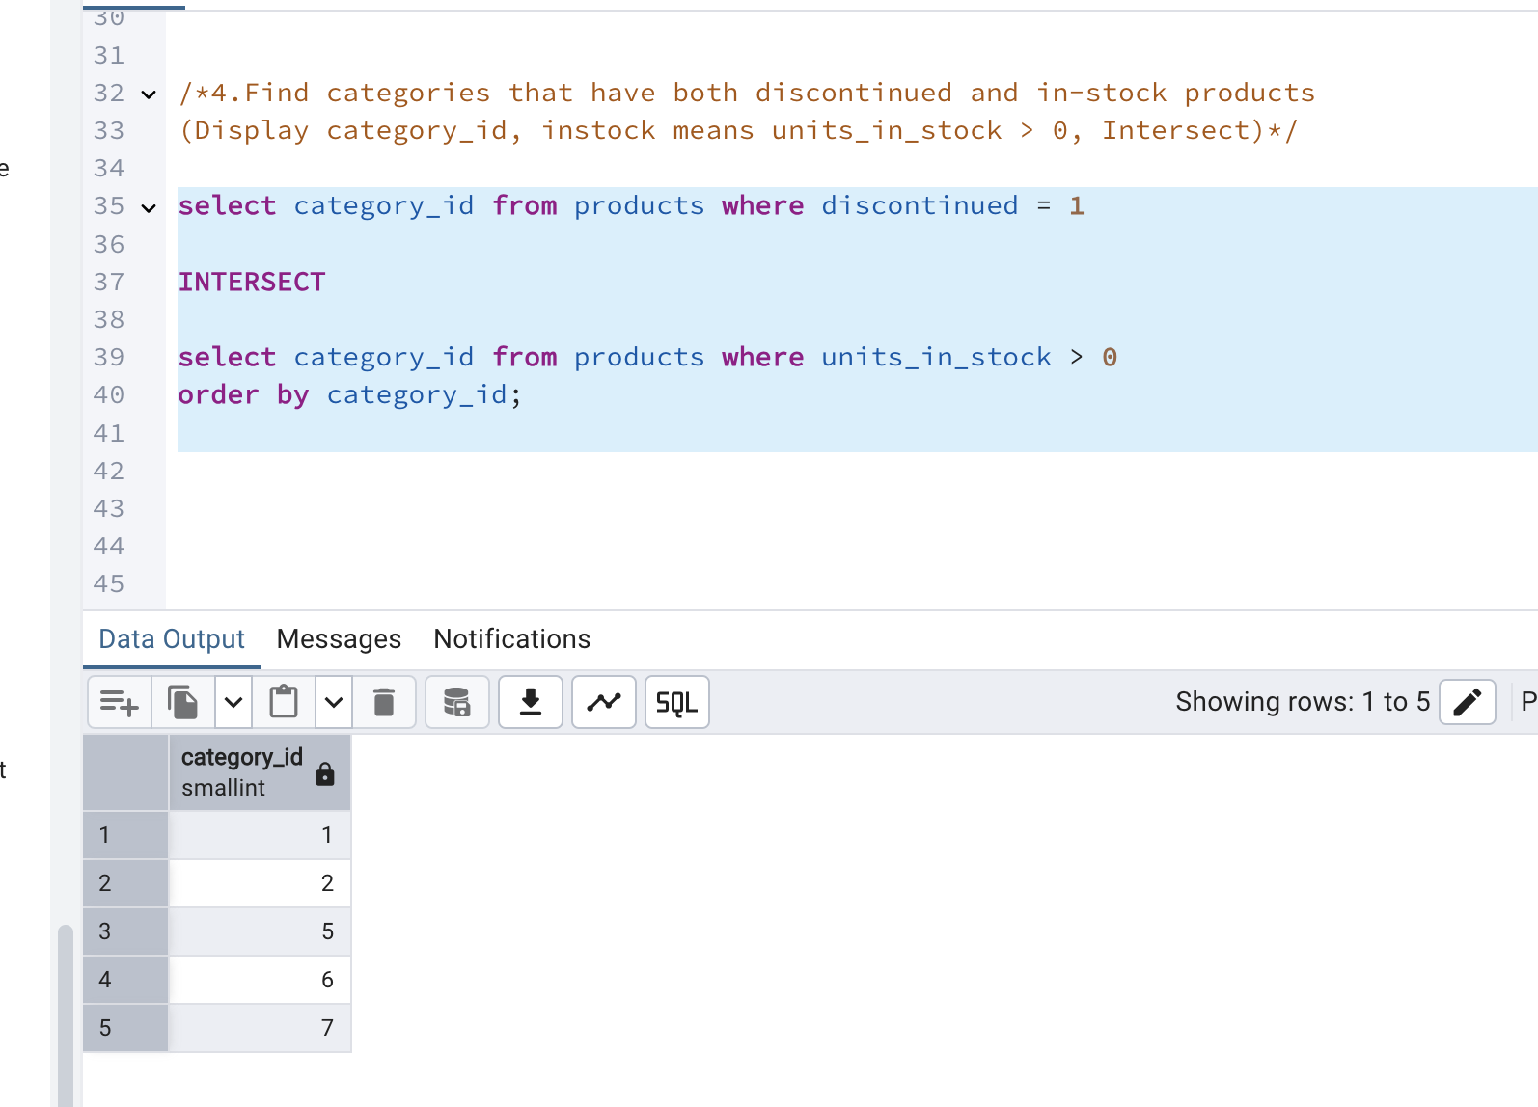

5.      Find orders that have no discounted items (Display the  order_id, EXCEPT)

 select order_id from order_details

EXCEPT

select order_id from order_details where discount>0;

